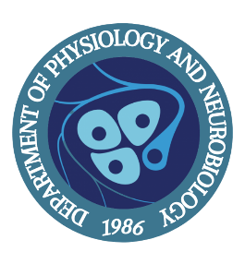
PNB Seminar Series

Lucas Cheadle, PhD
Assistant Professor
Cold Spring Harbor Laboratory

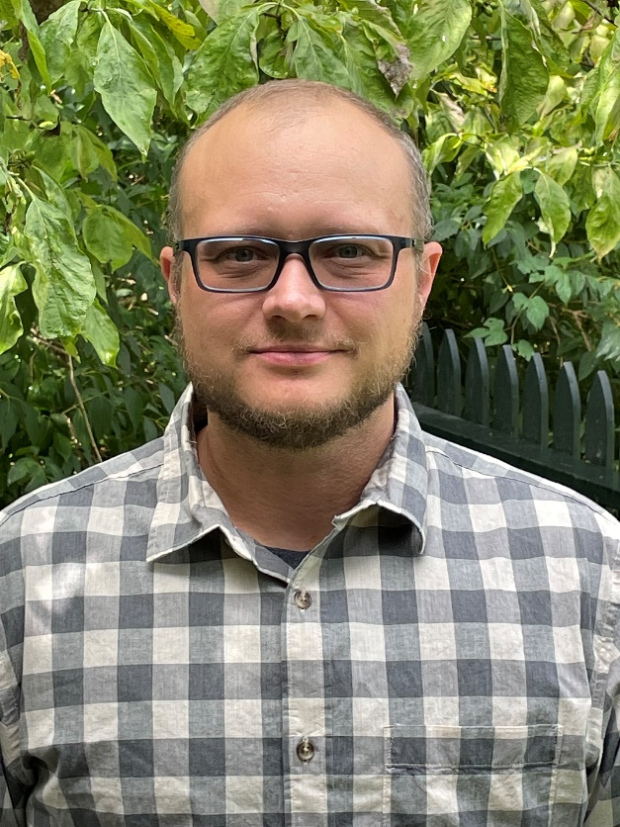

Wednesday, Nov 8, 2023

Seminar Time 4:00 – 5:00 pm
TLS Room 111

"Dynamic control of neural circuit refinement by oligodendrocyte precursor cells"

Host: Dr. Akiko Nishiyama

